
GUIDANCE FOR APPLICATIONS AGAINST FREEZING DECISIONS

The purpose of this Guidance is to explain the steps to be taken by those who are listed in United Nations Security Council (UNSC) Resolutions 1267 (1999), 1988 (2011), 1989 (2011), 2253 (2015), 1718(2006), 2231(2015) and their successor resolutions which are referred to in the Law on Countering Proliferation Financing and Law No 6415 on Prevention of the Financing of Terrorism of 07.02.2013 while applying against to these listings.

- General Information
The Law No 6415 on Prevention of the Financing of Terrorism was prepared within the scope of effective fight against terrorism and financing of terrorism for the purpose of determining the principles and procedures on implementing the “International Convention for the Suppression of Financing of Terrorism” dated 1999 and the United Nations Security Council Resolutions related to combating terrorism and the financing of terrorism within the context of this Law, on freezing of assets in line with the aim of establishing and preventing financing of terrorism offence. Afterwards, “Regulation on The Procedures and Principles Regarding The Implementation of Law on The Prevention of The Financing of Terrorism” and “MASAK General Communiqué No:12” were issued to demonstrate the implementation of the Law.
Besides, with the Countering Proliferation Financing (PF) Law, it was aimed at the implementation of UNSC resolutions 1718(2006) and 2231(2015) regarding the prevention of proliferation of mass destruction weapons by Turkey. Pursuant to paragraph 4 of Article 3 of the PF Law, the provisions of the Law No 6415 shall apply in the freezing of assets of those persons listed in UNSC Resolutions regarding the prevention of proliferation of weapons of mass destruction.
In this scope, pursuant to Article 5 of the Law No 6415 and paragraph one of Article 3 of the PF Law, assets of individuals, entities and organisations listed in UNSC Resolutions 1267 (1999), 1988 (2011), 1989 (2011), 2253 (2015), 1718(2006) and 2231(2015), and in their successive resolutions may be frozen with a decision published on the Official Gazette. Again, pursuant to Article 6 and 7 of the Law No 6415, assets of individuals, entities and organisations may be frozen spontaneously or upon the request of a foreign country in accordance with UNSC resolution 1373 (2001), through a decision to be published in the Official Gazette based on the existence of reasonable grounds that they have committed the acts given in articles 3 and 4 of the Law No 6415.
- Application Procedures Against the Decisions
  - Applications Made in accordance with the Norms of Domestic Law
Paragraph (2) of article 11 of the Law No 6415 covers the provision of “A decision on freezing of asset shall contain the identity of the person about whom the decision was made, reasons, scope, and expiration of the decision and legal remedies that can be applied against this decision and duration of application.”
Accordingly, the following statement was included into the Official Gazette “A case may be opened against this decision within the State Council in 60 days following the issuance of the decision in the Official Gazette pursuant to article 24 of the Law on the Council of State and article 7 of Administrative Judicial Procedures Law.
Based on the provision of “Relevant provisions of the Law No 6415 shall be applied as to implementation and results of the decisions made for freezing of assets pursuant to UNSC resolutions, provided that the provisions of this law are reserved.” stated in paragraph (3) of Article 3 of PF Law, this application procedure applies also to assets pursuant to the law aforementioned.
Moreover, concerned persons may request to review of the element of “reasonable ground” which is basis of the decision aforementioned by applying to the Assessment Commission or the Commission on Supervision and Cooperation, depending on what law is the basis of the asset freezing decision. An application mechanism different from those mentioned above is stipulated pursuant to paragraph (3) and subsequent paragraphs of Article 7 of the Law No 6415 in accordance with the regulations on “domestic freezing mechanisms”, accordingly, the decisions made by the Ministry of Treasury and Finance, and Ministry of Interior are submitted to Heavy Criminal Court. In accordance with Article 7(6) of the Law No 6415, the requests for repeal of asset freezing decisions should be made to the Assessment Commission. The commission makes assessments on the said requests and submit its proposals on this subject to relevant Ministers.
2.2. Applications made in accordance with UNSC Regulations
Paragraph (3) of article 5 of the Law No 6415 covers the provision of “Applications against the United Nations Security Council Resolutions shall be conveyed to the United Nations Security Council by MASAK through the Ministry of Foreign Affairs.”
In this framework, concerned persons may directly use application procedures provided by UNSC or if the applications are submitted to MASAK, they shall be conveyed to the UNSC by MASAK through the Ministry of Foreign Affairs.
2.2.1 Ombudsperson
Persons, entities and organizations whose assets are frozen pursuant to UNSC Resolutions 1267(1999), 1989(2011) and 2253(2015) can apply to Office of Ombudsperson established under UNSC Resolution 1904 (2009) directly by means of contact information given below or through MASAK to object to these decisions.
“Office of the Ombudsperson to the ISIL (Da'esh) and Al-Qaida Sanctions Committee
Room DC2-2206
United Nations
New York, NY 10017
United States of America
Tel: +1 212 963 2671
E-mail: ombudsperson@un.org “

Ombudsperson is an independent unit assigned directly by Secretary General of the UN and details of the procedure is given in the annex. (Annex-1) (https://www.un.org/securitycouncil/sites/www.un.org.securitycouncil/files/procedure_chart.pdf)
2.2.2 Focal Point
Persons, entities and organizations whose assets are frozen pursuant to UNSC Resolutions 1988 (2011) and 1718(2006) can apply to Focal Points established under UNSC Resolution 1730 (2006) directly by means of contact information given below or through MASAK to object to these decisions:
“Focal Point for De-listing
Security Council Subsidiary Organs Branch
Room DC2 2034
United Nations
New York, N.Y. 10017
United States of America
Tel. +1 917 367 9448
Fax. +1 212 963 1300
Email: delisting@un.org “

Details of the procedure for applying to Focal Point is given in the annex. (Annex-2) (https://www.un.org/securitycouncil/sites/www.un.org.securitycouncil/files/flowchart_dl_process_english.pdf )
In case of applications made to MASAK to object to Taliban-related asset freezing decisions made pursuant to UNSC Resolution 1988 (2011), MASAK also informs Afghan Government when necessary by taking paragraphs 18 – 24 of the said Resolution into account.
2.2.3 United Nations Security Council
Persons, entities and organizations whose assets are frozen pursuant to UNSC Resolution 2231 (2015) can apply to UNSC directly or through MASAK to object to these decisions depending on its relevance.

ANNEX-1 OMBUDSMAN PROCEDURE
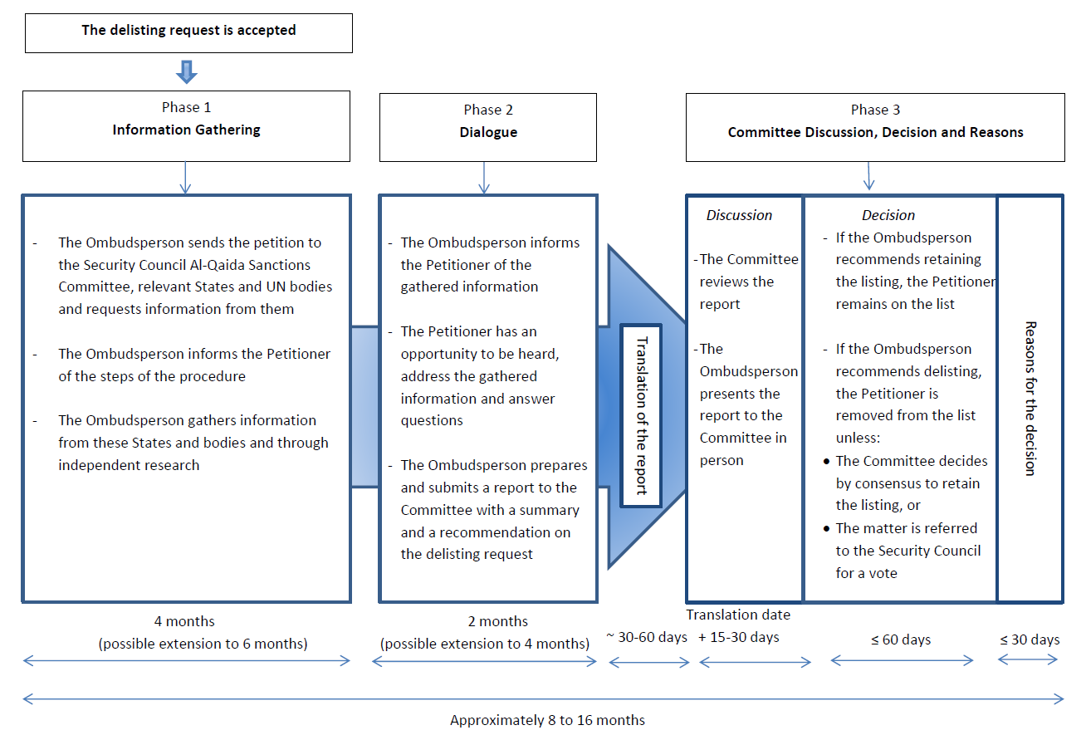
ANNEX-2 FOCAL POINT PROCEDURE
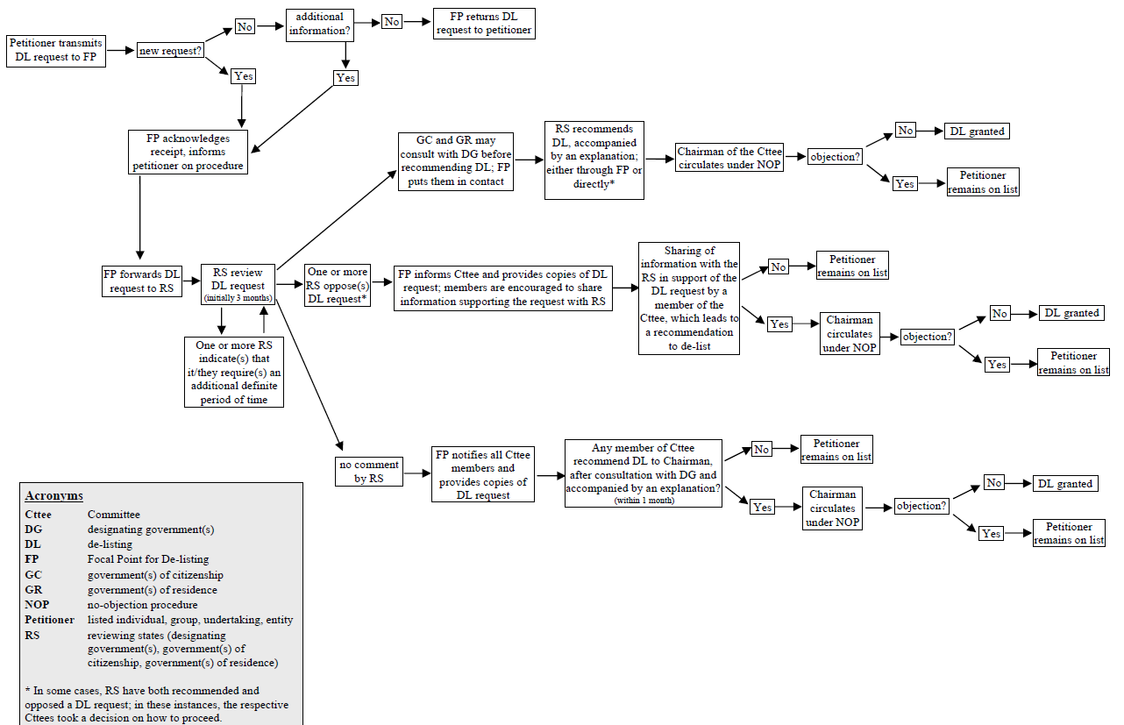

ANNEX-3
Petition Sample

T.R.
MINISTRY OF TREASURY AND FINANCE
To MASAK

My assets have been frozen pursuant to Decision published in Official Gazette No. ….., dated …… under TF Law / PF Law, and as it is stated in the information and documents annexed, it is considered that the Decision is not based on “reasonable grounds”.

In this regard, I request you to review the abovementioned asset-freezing decision. (…./…./2020)

Name/Surname
Signature

ANNEXES:
1-…......
2-………

Other units to which the petition is requested to be submitted

Ombudsperson

Focal Point

United Nations Security Council

https://www.resmigazete.gov.tr/eskiler/2019/01/20190110-10.pdf

