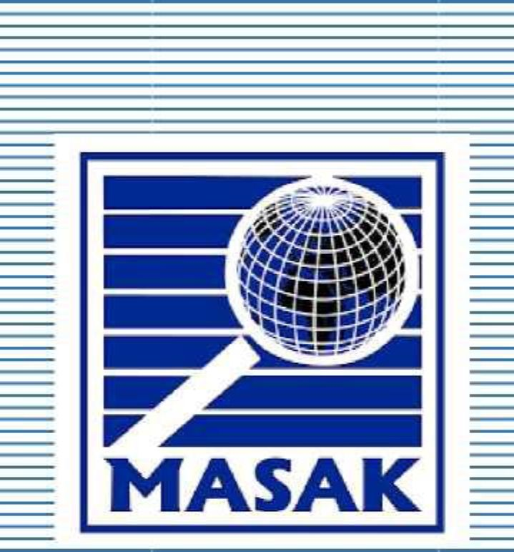REPUBLIC OF TURKEY  
THE MINISTRY OF TREASURY AND FINANCE

MASAK

GUIDANCE ON FALSE

POSITIVE CASES

The purpose of this Guidance is to set forth instructions for those who have frozen assets within themselves during the execution of asset freezing decisions made based on the Law No 7262 on Countering Proliferation Financing, Law 6415 of 07.02.2013 on the Prevention of the Financing of Terrorism, the Regulation of 31.05.2013 on Principles and Procedures of the Implementation of the Law on the Prevention of the Financing of Terrorism and MASAK General Communique 12.

1. General Information

Law 6415 on Prevention of the Financing of Terrorism was issued under the scope of an effectively combat against terrorism and the financing of terrorism (TF) for the purpose of establishing principles and procedures regarding the implementation of the International Convention for the Suppression of the Financing of Terrorism and anti-terror and CFT-related decisions of UNSC within the scope of the mentioned Law, regulating the TF offence, and freezing of assets for the prevention of TF. The Regulation on Principles and Procedures of the Implementation of the Law on the Prevention of the Financing of Terrorism and MASAK General Communique 12 were prepared for demonstrating the implementation of this Law.

Furthermore, the Law on Countering Proliferation Financing (PF) aims the implementation of the United Nations Security Council (UNSC) Resolutions in relation to PF such as 1718(2006) and 2231(2015) and in accordance with the Article 3(4) of the aforementioned law, the procedures detailed in Law No 6415 are to be also applied to the freezing/unfreezing of the funds or other assets in relation to PF.

Under the mentioned legal framework and in accordance with Article 5, 6 and 7 of the Law 6415, and Article 3 of the Law on Countering Proliferation Financing assets of individuals, entities or organisations may be frozen based on the on UNSC Resolutions 1267 (1999), 1988 (2011), 1989 (2011) , 2253 (2015), 1718(2006) and 2231(2015).

2. Legal Framework Regarding Name Similarity and Similar Situations

The article 12 (2) of Law No. 6415 contains the following provision:

“MASAK is responsible for the execution of the decision on freezing of asset made in accordance with the provisions of this Law.”

Within this framework, article 14 (6) of the Regulation on the Procedures and Principles regarding the Implementation of Law on the Prevention of the Financing of Terrorism contains the following provision:

“*The unfreezing request related to misapplied asset-freezing decisions of Presidency due to name similarity*, *f*alse or missing identity information and similar grounds *shall be made to MASAK* in writing with the justification by annexing relevant documents, if any. In cases where MASAK approves the request, unfreezing shall be applied by notifying institutions and organizations, and natural and legal persons stated in this Article without delay”

Also, within this scope, The MASAK General Communique (No:12) contains the following provision:

“2.5. *Uncertain Situations in Execution of Freezing Action*

On the other hand, if the person whose assets are frozen claims that she/he is not the person listed by the United Nations Security Council (UNSC) Resolution, and an erroneous freezing action has been taken due to *name resemblance, incorrect or deficient identity information and similar reasons, the objection should be made to MASAK in writing together with its grounds and by* *adding relevant documents, if any.* If MASAK approves, the situation shall be informed to liable parties immediately and the erroneous freezing action shall be corrected.”

Furthermore, Article 3(4) of the Law on Countering Proliferation Financing reads as follows:

“Relevant provisions of the Law No.6415 shall apply as to execution and consequences of the decisions on freezing assets made pursuant to UNSC resolutions, without prejudice to the provisions in this law.”

Therefore provisions of the Law No 6415, including the procedures in relation to resolving false positive cases, are applicable in instances relevant to the implementation of UNSCR 1718(2006) and 2231(2015).

Case Study

In the Presidential Decision published in the Official Gazette dated 27/11/2018 with the number 30608, the person named “Abu Luqman” was decided to be listed and the assets of him were frozen for being associated with DAESH and Al-Qaeda.

LIST

A. NATURAL PERSON ASSOCIATED WITH DAESH AND AL-QAEDA

1. Name-Surname: 1: ANJEM 2: CHOUDARY Title : -

Occupation : -

DOB : 18 January 1967

POB : Welling, London, United Kingdom of Great Britain and Northern

Ireland

Nationality : United Kingdom of Great Britain and Northern Ireland

No.516384722, issued on 06/05/2013 (Issued by Glasgow Passport Office, Validity Date: 06/06/2023)

National ID No : -

Address : Frankland Prison, United Kingdom of Great Britain and Northern

Ireland

Figure 1-Official Gazette dated27/11/2018 with the number 30608

Upon publication of the decision in the Official Gazette, X Bank, located in Turkey, froze the account of Abu Luqman (DOB: 24/12/1978, Nationality: Country Y) in the branch Istanbul/ Bağcılar at the same date and reported to MASAK on 28/11/2018.

The notification sent to the address of Abu Luqman, in accordance with article 12 of the Regulation on the Procedures and Principles Regarding the Implementation of Law on the Prevention of the Financing of Terrorism, by MASAK on 28/11/2018 was reached and the person concerned learned that his bank account at the İstanbul/Bağcılar branch of Bank X was frozen on the same date.

In the given example, it is seen that the date of birth, citizenship and current address information of Abu Luqman is different from the person who is included in the Official Gazette dated 27/11/2018 - 30608 and whom the freezing decision is wanted to be applied. In this context, it is required to sent the sample petition in Annex-1 by filling in and adding a copy of the passport, ID card and/or other related information and documents to the address “Ministry of Treasury and Finance, MASAK, A Block, Dikmen Caddesi, Dikmen , Çankaya/ANKARA” by mail.

Within the framework of the information and documents presented and as a result of the study carried out by MASAK, it is determined that the relevant person (Abu Luqman) is not the targeted person and there is only a name similarity. The processes for unfreezing of assets shall be implemented by MASAK without any delay by sending an article both to the party implemented the freezing decision and to the other relevant third parties.

ANNEX-1  
Sample Petition

**THE REPUBLIC OF TURKEY  
MINISTRY OF TREASURY AND FINACE  
MASAK**

With the decision published in the Official Gazette dated………..and numbered……………*, the assets of person/institution/organization named* were frozen in accordance with Law No.6415/ 7262 and applied by ** to me erroneously due to name resemblance, incorrect or deficient identity information and similar reasons.

As understood from the annexed document and information, due to the reasons*** ……………………………………… the freezing transaction was erroneously made and applied to a third party different from the targeted person in the relevant decision.

Within this framework, I request that the freezing transaction, which was foreseen to be applied to the assets of the person by the decision, published in the Official Gazette dated and numbered, but erroneously applied to me being repealed.

Kindly submitted for information and necessary actions. (..../.. ../2020)

**Name/Surname**

**Signature**

**ANNEXES:**

1-

2-

* The name or the title of the person/institution/organization shall be written.

** The name and contact details of the party that applies the freezing decision shall be written.

*** Descriptions of why the freezing decision is erroneous shall be written.